SCSI
SCSI (Small Computer System Interface) is an advanced controller technology, which is especially used in high-end PC’s. These can be network servers or just powerful workstations, for which there are a number of different SCSI standards. The SCSI bus can transfer up to 160 MB/second, which is more than the PCI bus can deliver.
A SCSI system is built around a central controller, called the host adapter, which is almost a tiny computer in its own right. The adapter can be quite expensive if, for example, it has to be used with very fast hard disks. However there are simpler SCSI adapters, for example, those sold with SCSI based scanners.
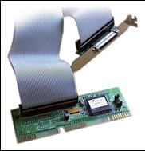 | Figure.  A small SCSI controller. Note the wide cable.
The best known manufacturer of SCSI adapters is Adaptec. It used to also be quite common for motherboards to have built-in SCSI controller – often of high quality.
A host adapter can control a number of SCSI devices, which are connected in a long series (a chain). Every device is allocated an identification number, and a terminator has to be put in at both ends of the SCSI chain. This is done, for example, using a jumper on one of the devices.
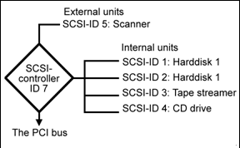

The SCSI controller has its own startup routine in which it identifies the devices which are connected.

USB
USB stands for Universal Serial Bus and is an I/O standard originally developed by seven companies – Compaq, Digital, IBM, Intel, Microsoft, NEC and Northern Telecom (see the USB Implementers Forum at www.usb.org).
USB is a cheap serial I/O bus with an open specification. This means that anyone can produce USB products, without having to pay licences to anyone.
USB has been the biggest and most welcome innovation in PC design seen for many years. It is an expansion bus which allows a vast amount of PC equipment to be connected. It’s suddenly possible to connect loads of different gadgets to the PC – and using just one type of connector! And USB devices can also be used both with Macintosh computers and PC’s – yet another advantage.
USB has been advertised since 1994, and for many years it was called the Useless Serial Bus. But starting in 1999, production finally surged forward, and there are now thousands of different USB gadgets.
USB unifies all the different connections for keyboard, mouse, scanner, joystick, digital camera, and perhaps printer, onto a shared bus – connected using a common connector type.
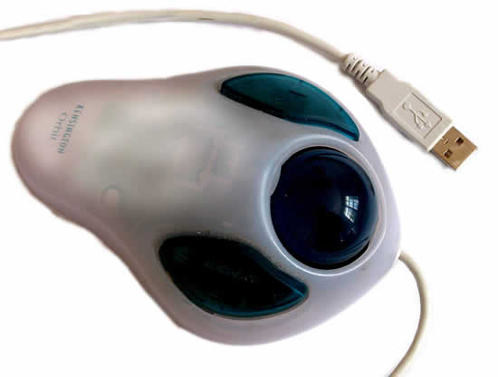
A USB-based trackball – actually designed for Macintosh computers, but works fine on PC’s.

USB – the technology
From a technical viewpoint, the following can be said about USB:
- The transfer speed is limited to a maximum of 12 Mbit/sec. in USB version 1.1. It is therefore primarily used for equipment which doesn’t require a large bandwidth.
- USB version 2.0 has a bandwidth of 40 MB pr. second, and is used in all modern computers. USB version 2.0 is backwards compatible. The same type of connector is used, and old devices can be connected to the new controllers.
- USB is a serial connection using just four conductors (in contrast to the 50 or so used for a PCI device). This makes manufacturing much easier and cheaper.
- The USB cable can also supply power to the devices. This means that scanners, for example, don’t have to have their own power supply. The maximum cable length is 5 meters.
- Up to 127 USB devices can be connected to the PC using USB hubs.
- There are no IRQ’s to be configured or terminators etc. USB devices can be connected ”On the fly”, without restarting the PC.
There has to be a USB host controller in the PC in order to be able to connect the devices. This controller can be bought separately, as an adapter, but most motherboards have one built into the chipset’s south bridge. There are typically two or four USB connectors on the motherboard, but you can have many more USB devices than this if you connect an extra hub.
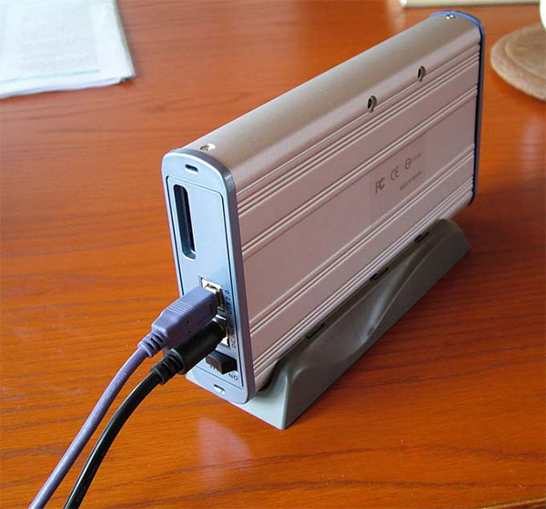

SATA
SATA is abbreviated as Serial AT Attachment. The name "AT" Attachment was introduced after the invention of the IBM personal computer in 1984.
Serial ATA or SATA is a computer bus interface for connecting the storage disks or drives to the motherboard of computer systems. SATA standards help in transferring data from hard drives and optical disk drives to computer systems.
Serial ATA (SATA) was created by the serial ATA working group in 2000. Serial ATA was introduced to provide various benefits over the previous Parallel ATA interface, which was announced around the 1980s. In January 2003, Seagate Barracuda SATA V was the first hard disk drive in the world. In 2008, the Serial ATA hard drive replaced the parallel ATA in the consumer's desktop and laptop computers.
The first version of SATA (SATA 1.0) can easily communicate 1.5 Gbps of performance to each storage drive within a disk array. In comparison to earlier ribbon cables which are used with ATA drives, the cable of serial ATA provides the best airflow in the computer systems and makes the routing easier.
SATA also uses external hard drives through external SATA. External SATA is commonly referred to as eSATA. eSATA drives are hot-swappable and providing high transmitting speed with no USB and FireWire issues.
Fast transmission speed, high performance, and outstanding storage capacity are the two main characteristics of SATA hard drives.

SATA Cables
The SATA cables are long, and both end-points of the cable are thin and flat.
SATA cables are of different types, but the following two are the main types of SATA cables:
- SATA Data Cables: These cables typically have seven pins for transferring data. These connect the drives to the motherboard of the computer systems. One end of the SATA cable plugs into the back of the hard drive of the computer system and the other end plugs into the computer's motherboard.
- SATA Power Cables: These cables typically have fifteenth pins. These connect to the power supply.
Let's discuss other types of serial ATA cable one by one.

Other Types of SATA Cables
Some other different types of SATA cables are given below:
- e-SATA: This cable joins the external devices into our computer systems with a length ranging from 0.5 - 2 meters long.
- SATA Bracket: It is a dual-port eSATA expansion bracket which makes our computer output compatible with the SATA external devices.
- SATA Bridge: This SATA cable connects the ATA devices to the SATA motherboard or PCI cards. This interface is a bridge between the SATA devices.
- Low Profile SATA: It is a quite thin SATA cable with a very simple and low profile connector. This SATA cable can be used easily with longer graphic cards.
- Micro SATA: This SATA cable is used for internal disks and backplane applications.
- SATA-SATA: It is a standard data cable which is available in various lengths and can be used for standard SATA applications.

Revisions of SATA Interface
Following are the three major different revisions of the SATA interface:
SATA I: This interface is formally called SATA 1.5Gb/s. It is the first generation of SATA, whose speed is running at 1.5 Gigabit per second.
SATA II: This interface is formally called SATA 3Gb/s. It is the second generation of SATA, whose speed is running at 3.0 Gigabit per second.
SATA III: This interface is formally called SATA 6Gb/s. It is the third generation of SATA, whose speed is running at 6.0 Gigabit per second.
